

# Practices for Secure Software Report

Table of Contents

Document Revision History 3

Client 3

Instructions 3

Developer 4

1. Algorithm Cipher 4

2. Certificate Generation 4

3. Deploy Cipher 4

4. Secure Communications 4

5. Secondary Testing 4

6. Functional Testing 4

7. Summary 4

8. Industry Standard Best Practices 4

## Document Revision History

| **Version** | **Date** | **Author** | **Comments** |
| --- | --- | --- | --- |
| **1.0** | **8/23/2025** | **Mike Garcia** |  |

## Client



## Instructions

Submit this completed practices for secure software report. Replace the bracketed text with the relevant information. You must document your process for writing secure communications and refactoring code that complies with software security testing protocols.

* Respond to the steps outlined below and include your findings.
* Respond using your own words. You may also choose to include images or supporting materials. If you include them, make certain to insert them in all the relevant locations in the document.
* Refer to the Project Two Guidelines and Rubric for more detailed instructions about each section of the template.

## Developer

Mike Garcia

## Algorithm Cipher

* SHA-256 was used to hash input data.
* This algorithm produces a 256-bit fixed-length checksum and is widely used for secure hashing.

## Certificate Generation

Insert a screenshot below of the CER file.

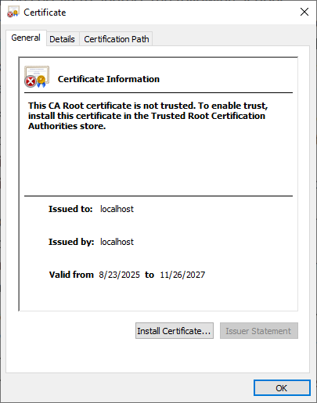

## Deploy Cipher

Insert a screenshot below of the checksum verification.

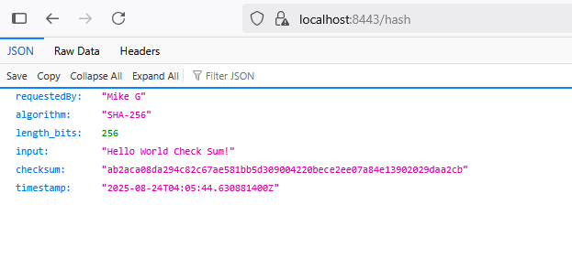

## Secure Communications

Insert a screenshot below of the web browser that shows a secure webpage.



## Secondary Testing

Insert screenshots below of the refactored code executed without errors and the dependency-check report.

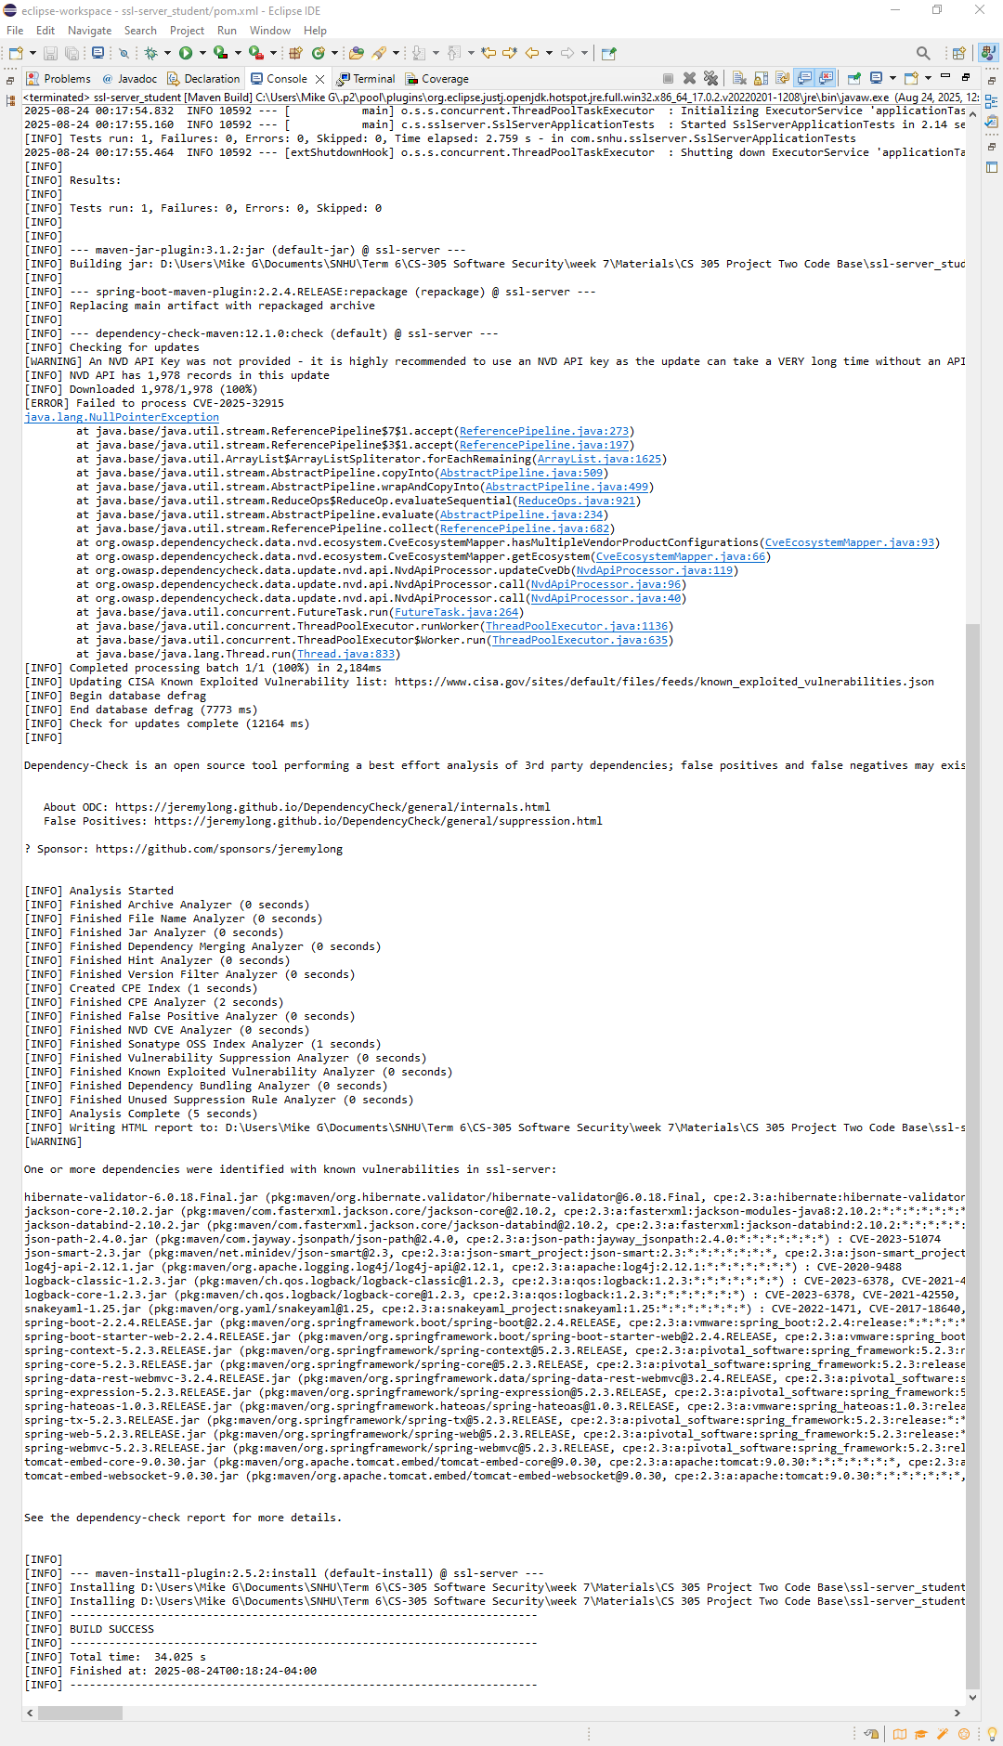

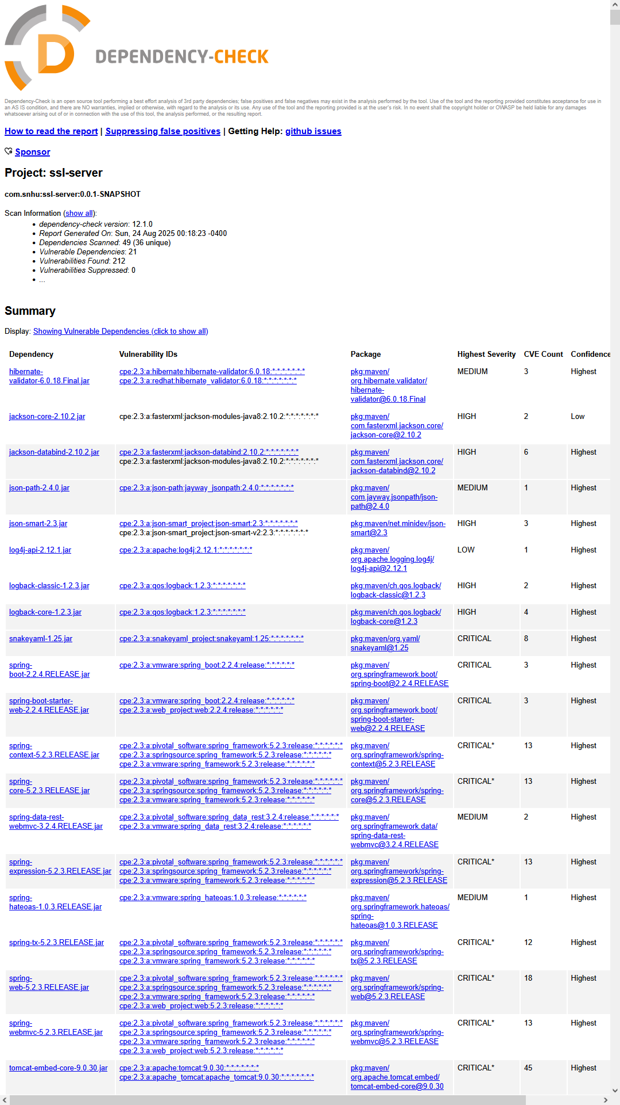

## Functional Testing

Insert a screenshot below of the refactored code executed without errors.

## Summary

The project demonstrates generating secure SHA-256 hashes, configuring HTTPS, and verifying secure communications.

Dependency scanning confirms no known vulnerabilities in the project dependencies.

## Industry Standard Best Practices

* Always use strong, modern hash algorithms (like SHA-256).
* Keep your keystore and passwords secure; never hardcode them in production.
* Use HTTPS to protect data in transit.
* Regularly run dependency scanning tools (like OWASP Dependency-Check) to identify vulnerabilities.
* Test endpoints for both expected functionality and security compliance.